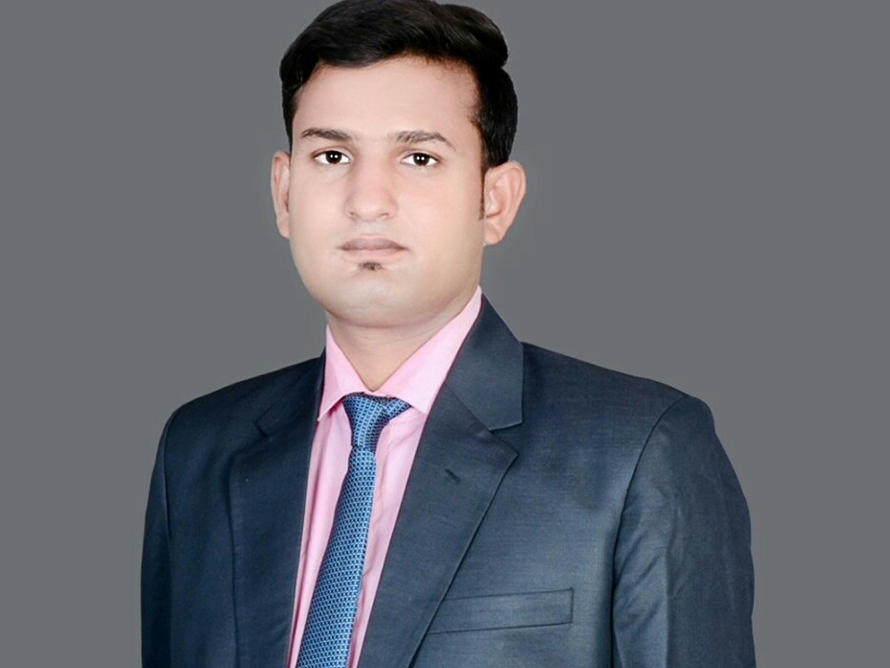

Mobile: +91-9997248423|| E-Mail:ajnkit77kumar@gmail.com

MILLS,

**ANKIT KUMAR**

**SITE ENGINEER**

Targeting assignments in ***Civil Engineering/ Finishing / MEP/ Interior Works*** with an organization of repute in ***Construction*** industry, preferably in ***any where in India***

|  |  |
| --- | --- |
| **Pursuing MBA**(Project Management) from UPTU  **B .Tech. (Civil)** from Shanti Institute of Technology Meerut (UPTU Lucknow) in 2014; scored 78%.  **12th**from PBAS Inter college, Modinagar, GZB, UP Board in 2010; scored 67%.  **10th** from Krishak High School, Churyala, GZB, UP Board in 2008; scored 50%. | **PROFILE SUMMARY**   * **B. Tech. (Civil)** professional with **over 4.5 years** of experience * Experienced at applying the **principles of civil engineering** when planning, designing and supervising the construction activities * Successfully executed key projects such as construction of **New Fivestar Hotel, power plant project, Factory Building etc** * Comprehensive knowledge of relevant civil engineering design software entailing **AutoCAD 2D, 3D** * Proficiency in using survey equipment and capability to evaluate designs, plans and projects * Key focus on **monitoring all site related activities** & ensuring their smooth execution as per project schedule with focus on optimum utilization of manpower & materials * An excellent communicator with strong leadership, decision-making, interpersonal, analytical & problem-solving skills |

**CORE COMEPTENCIES**

***~ Project Planning & Execution ~ Material Management ~ Labour Management***

***~ Site Billing ~ Construction & Site Administration ~ Civil Engineering***

***~ Liaison & Coordination ~ Drawing Study for Construction Related Work***

***~ Safety Management ~ AutoCAD***

**ORGANISATIONAL EXPERIENCE**

**April’ 18 till date**

**Knight Frank Gurugram as a Asisstant Project Manager**

**Project Title: Cooperate Office of Paytm, Noida**

**Role:**

* Studying drawings and ensuring work is conducted as per the drawings (civil, finishing, interior)
* Liaising with Project Management Team and Planning Engineer regarding construction programmes
* Resolving technical issues with clients representatives, suppliers, subcontractors and statutory authorities
* Checking materials and work in progress for compliance with the requirements and ensuring adequate supply of resources such as manpower and materials
* Coordinating with site inspectors to check the on going project status and for development for quality control in compliance accordance with method statements, quality plans & safety regulations
* Maintaining reports of contractors for proper execution of key projects on a daily basis
* Identifying problems and areas of non-conformance and initiating/ recommending corrective actions
* Reading design specifications and technical drawings
* Liaising with client & consultants and monitoring third party contractors

**Highlights:**

* Played a key role in taking various measures to conclude projects on time and within budget
* Received several appreciation from clients
* Ensured successful completion of the prestigious project within approved budget

**Apr’16 – Mar'18**

**Sam's Groups Noida as a Sr. Site Engineer**

Project Title : Five Star hotel, Bareilly

**July’15 – Apr’16**

**Titan biotech ltd, Bhiwadi as a Site Engineer**

Project Title : factory Building, Chemical Labs, ETP, Boiler Foundations etc.

**Jul’14 – Jun’15**

**KRBL Limited, Ghaziabad as a Civil Engineer**

**Project title: Power plant project, Godowns, Ware House**

**INDUSTRIAL TRAININGS**

**Organization:** A to Z Builders and Developers Pvt. Ltd, Meerut

**Period: Apr**’2013– Dec’13

Project title: Duplexs. Simplexs, Villas etc

**Organization:** Aisthvinayak Builders Pvt. Ltd., (Construction)

**Period:** Jan’14 – Jun’14

Project title: Heart of centre (Hospital) , Gr. Noida

**EXTRACURRICULAR ACTIVITIES**

* Displayed excellence while participating in:
* Fest Tech in 2014
* Various events at college level
* Contributed in APOGEE 2014 & 2015
* Actively participated in Tree Plantation Camp at school

**IT SKILLS**

* AutoCAD and Internet Applications
* MS Word
* MS Excel
* C++

**PERSONAL DETAILS**

**Date of Birth:** 1st October 1993

**Languages Known:** English & Hindi

**Address:** Vill. Moradabad Post Mohiuddinpur

Tehsil Modi Nagar

Distt Ghaziabad U.P.